Assignment 9-
Jenkins master–slave assignment, the idea is:
- Jenkins Master → Builds the project and creates the WAR file
- Jenkins Slave (Agent) → Has Tomcat installed, and Jenkins deploys the WAR there
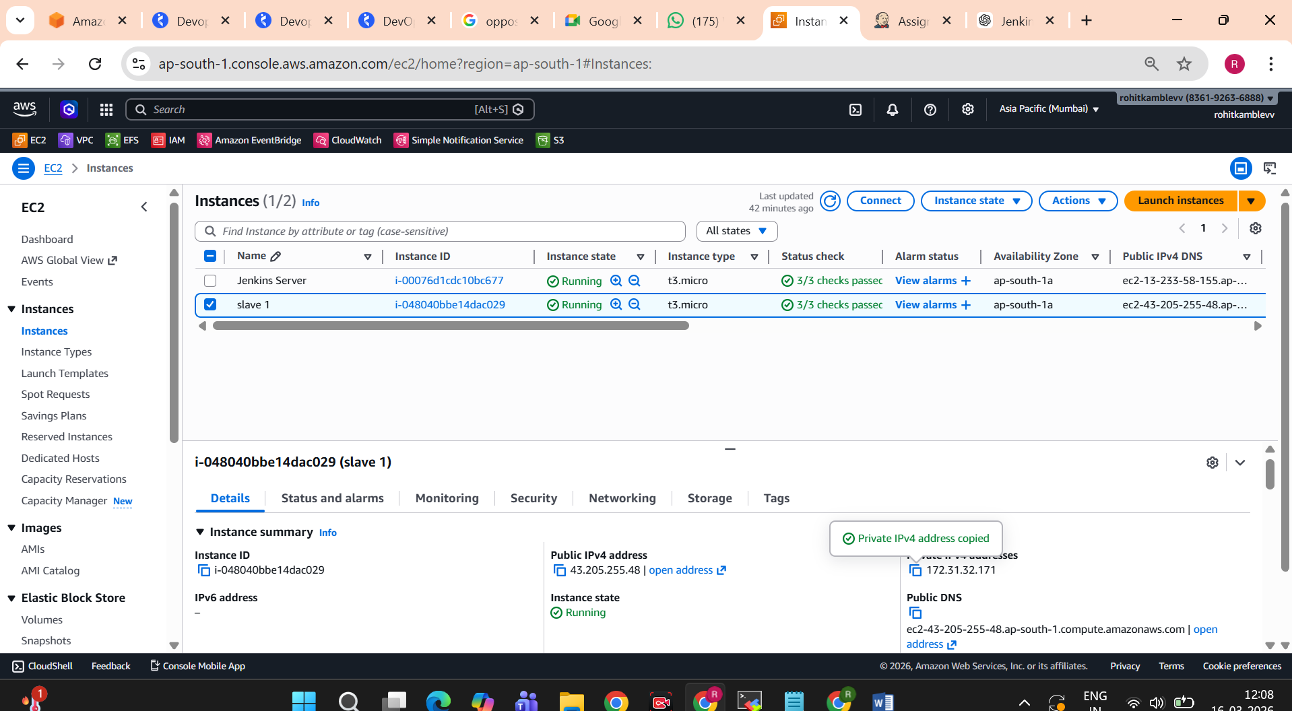
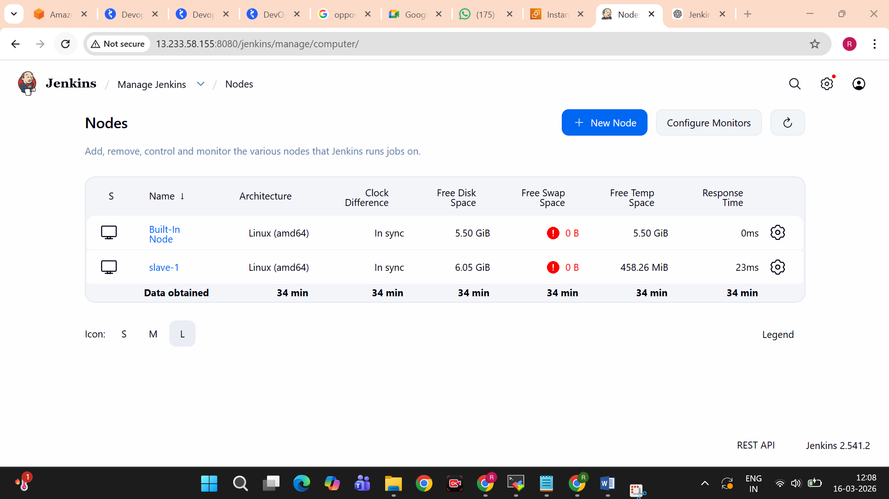

scp -o StrictHostKeyChecking=no -i /mnt/mumbai.pem target/*.war ec2-user@172.31.32.171:/tmp

ssh -o StrictHostKeyChecking=no -i /mnt/mumbai.pem ec2-user@172.31.32.171 "

sudo rm -rf /mnt/apache-tomcat-10.1.52/webapps/*.war
sudo cp /tmp/*.war /mnt/apache-tomcat-10.1.52/webapps

sh /mnt/apache-tomcat-10.1.52/bin/shutdown.sh
sh /mnt/apache-tomcat-10.1.52/bin/startup.sh

"
